**C.A. Roberts Elementary**



**School Improvement Plan**

**2024 -2025**

**Paul Wilder, Principal**

PCSD VISION

PCSD MISSION

***The vision of the Paulding County School System is to prepare ALL students for success today and tomorrow.***

***Engage. Inspire. Prepare.***

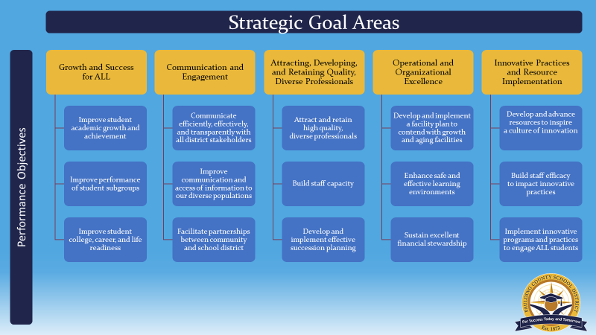

SCHOOL MISSION & VISION

**Our Vision**

Our vision is to create a safe, engaging, and cooperative learning community, in partnership with all stakeholders, which meets the diverse needs of students, empowering them to become active citizens that are independent, life-long learners striving for excellence.

**Our Mission**

Realizing Our Capabilities, Keeping Everyone Targeted for Success

**Our Motto**

We are STARS with GRIT shooting for the stars!



|  |  |  |  |  |  |
| --- | --- | --- | --- | --- | --- |
| ***Roberts Elementary School Improvement Action Plan***  ***SMART Goal 1: Increase percentage of students scoring in level 3 and level 4 on the ELA sections of the Georgia Milestones end of grade assessment from 43.4% (2024) to 47% on the spring administration.***   * ***Increase percentage of 3rd grade students scoring level 3 and level 4 on the ELA sections of GMAS from 36% to 47%.*** * ***Increase percentage of 4th grade students scoring level 3 and level 4 on the ELA sections of GMAS from 36% to 41%.*** * ***Increase percentage of 5th grade students scoring level 3 and level 4 on the ELA sections of GMAS from 45.5% to 50%.*** * ***Sub goal for SWD students to increase percentage of students scoring in level 2- 4 on the ELA sections of the Georgia Milestones end of grade assessment from 49.1% (2024) to 53% on the spring administration.*** | | | | | |
| **Strategic Goal Area** | **Initiatives/Action Steps** | **Process Goals**  **(Guide your Action Steps – benchmarks along the way)** | **Person(s)**  **Responsible** | **Monitoring** | | |
| **Implementation**  **(Artifacts/Evidence)** | **Effectiveness**  **(Formative Data)** | |
| **Strategic**  **Goal 1A, 1B, 1C, 2B, 4B** | Teachers will utilize Write Score to supplement writing instructional planning.  Teachers will follow the Bookworms pacing guide to implement the writing component with fidelity.  Engage in data digs that analyze Write Score results and emphasize use of data in student conferencing. | Calendar PL to support Bookworms writing and Write Score by the end of August    School administrators and the literacy coach will review writing lesson plans bi-weekly    Write-Score Administration:  Informational Writing – October 2023  Opinion Writing– January 2024    Conduct classroom observations during writing and provide feedback on the implementation of Bookworms Writing and Write-Score. (2 total – one first semester and one second semester)    Monitor subgroup writing data during team meetings. | Classroom Teachers  Support from Reading Coach, District Writing Coach, and Administrators  Teachers  Reading Coach and School Administration  Teachers, Reading Coach, and School Admin | PL calendar    Writing lesson plans    Write Score Reports    PLC agendas, sign in sheets and meeting summaries    Classroom observation forms | Write Score Data    Collaboratively scored student writing samples with rubrics    Classroom observation forms | |
| **Strategic Goal 1A, 1B, 1C, 2B, 4B** | Teachers will Continue Implementation of Bookworms Reading for K-5 by following the pacing guide.  Trained teachers will continue to implement Fundations and Sonday System following the programs’ procedures  in K-2 and 2-5.  Teachers in K-2 will be trained on and begin the Implementation of Smarty Ants, following the program with fidelity. | Conduct Data Fishbowls at the end of each DI cycle (15 days)  Follow-up with feedback and coaching support by literacy coach and/or district level support monthly  Provide monthly PL through Literacy Trainings.  Quarterly literacy walks by district and/or school administrators  Monthly observations with provided feedback  School administrators and literacy coach will review weekly lesson plans in all areas of reading  Monitor subgroup data between each DI cycle  Monitor reading data monthly through MTSS meetings.  Provide MTSS support in reading monthly. | Classroom Teachers  Support from Reading Coach, District Writing Coach, and Administrators  Reading Coach  Reading Coach, Admin, and District Personnel  Reading Coach    School Admin and Reading Coach  Teachers;  Reading Coach, and  School Admin  Teachers,  Reading Coach,  Admin, and Michelle Banta | PL Calendar  PLC agendas, sign-in sheets, and meeting summaries  Observation forms by administrative team, reading coach, and district personnel  Teacher lesson plans in reading | Students will increase reading and Lexile scores on the following measures:   * Acadience * Skills Tests * Spring GMA * Beacon   Student achievement data through MTSS interventions in reading will increase.  Subgroup reading data will improve. IRR teachers observed by Literacy Coach will receive specific feedback regarding small groups and co-taught instruction for shared, interactive, and DI lessons. | |

|  |
| --- |
| ***Roberts Elementary School Improvement Action Plan***  ***SMART Goal 2: Increase percentage of students scoring level 3 and level 4 on the Mathematics sections of the Georgia Milestones end of grade assessment from 50.2% (2024) to 53% in the spring administration.***   * ***Increase percentage of 3rd grade students scoring level 3 & 4 on the Mathematics sections of GMAS from 56.1% to 58%.*** * ***Increase percentage of 4th grade students scoring level 3 & 4 on the Mathematics sections of GMAS from 54.5% to 58%.*** * ***Increase percentage of 5th grade students scoring level 3 & 4 on the Mathematics sections of GMAS from 38.8% to 42%.*** * ***Sub goal for SWD students to increase percentage of students scoring in level 2 - 4 on the mathematics sections of the Georgia Milestones end of grade assessment from 58.2% (2023) to 61% on the spring administration.*** |

| **Strategic Goal Area** | **Initiatives/Action Steps** | **Process Goals**  **(Guide your Action Steps – benchmarks along the way)** | **Person(s)**  **Responsible** | **Monitoring** | |
| --- | --- | --- | --- | --- | --- |
| **Implementation**  **(Artifacts/Evidence)** | **Effectiveness**  **(Formative Data)** |
| Strategic Goal 1A, 1B, 1C, 2B, 4B | Teachers will follow the MTSS flow chart to implement Do the Math (DTM), Acadience Math, and Basic Fact Fluency (BFF) during their designated Needs-Based-Instruction (NBI) time.  Teachers will implement Illustrative Math curriculum in grades K-5.  All teachers will develop knowledge to drive instruction using grade-level specific mathematics standards. | Continue to provide math support to develop understanding and usage of Illustrative Math curriculum.  Administer the Math Beacon Assessments  Observe common planning and classroom instruction. Use Illustrative math walkthrough form developed by the county.  Monitor sub-group math data between DTM cycles and through Assessment Review Meetings.  Monitor common assessments (unit assessments). Adjust Friday instruction according to unit assessment data. | School Admin  District Math Coaches  EAC  District Math Coaches  Teachers  Administrators  Teachers  Administrators  Teachers  Administrators | Professional Learning Calendar  Teacher lesson plans  PLC agendas, sign-in sheets, meeting summary forms  Do the Math rosters / groupings  Observation forms / comments by administrative team and District personnel  Common Assessments along with data.  October and February – data review including domain data for Milestones and Beacon. | Student achievement data will increase in the following:   * Beacon * DTM Assessments * Classroom / Common Assessments   Student achievement data in math through MTSS interventions with increase.  Subgroup data in math for ESEP students will improve.  Spring 2024 Georgia Milestones Assessment data will improve. |

***Roberts Elementary Professional Learning Plan***

| **Professional Learning Strategy/Support**  (**Should be connected to effectiveness monitoring of action steps in the SIP**) | **Audience** | **Presenter** | **Timeline** | **Monitoring** | |
| --- | --- | --- | --- | --- | --- |
| **Implementation** | **Effectiveness** |
| Professional learning provided by the district and school literacy coach on the Science of Reading through the Bookworms program (Shared, Interactive, DI, System 44, Read 180, Fundations, Smarty Ants, and Sonday System) to improve Lexile Scores will be provided to teachers and administrators by district level reading support throughout the 2024-2025 school year. Professional learning will include follow-up with feedback and coaching support by literacy coach and/or district level support.  Through L4GA Grant II funding, K-5 teachers will be provided opportunities to observe and discuss implementation for DI, Shared, Interactive, System 44, and Read 180 strategies with opportunities for authentic peer observations. | Classroom Teachers and Support Staff | Kim Freedman, Cydney Turner, teachers, and admin team | August 2024-May 2025  Monthly Data Reviews | Data Fishbowl Sign-In Sheets per Cycle  Professional Learning Calendar  PL Agendas  Teacher Lesson Plans  Classroom observation feedback by Reading Coach and Administrative Team.  Focus of observations using the coaching walkthrough forms focused on student voice (turn and talks), questioning, and teacher focuses on standards within lesson cycle of Shared and Interactive.  Literacy Walk Feedback | Students will increase reading and Lexile scores on the following measures:   * Acadience * Skills Tests * Spring GMA * Growth Measure   Teachers will demonstrate knowledge of adjustments made to groups and specifically types of questioning and expectations of student voice in turn and talks and written responses. |
| Professional learning provided throughout the 2024-2025 school year on how to create, implement, monitor, and evaluate students progress through Project-Based-Learning (PBLs). Professional learning will include follow-up with feedback and coaching support by school administration and presenters. | Classroom Teachers and Support Staff | STEM Teacher, Vetnure Teacher, Administrators | August 2024-May 2025  Per Unit Change and as needed | PLC Sign-In Sheets per Cycle  Professional Learning Calendar  PL Agendas  Teacher Lesson Plans  Classroom Observation Feedback | Student achievement data will increase in:   * Beacon Assessments * Classroom assessments * Spring 2025 GMA * MTSS interventions   Walkthrough data will reflect effectiveness of turn and talks and student written responses. |

Supports that may be included:

* PLC work
* Coaching sessions with Individual Teachers
* Mentors
* Online Professional Learning Opportunities
* Paraprofessional PL Opportunities
* Ongoing District or School provided PL